**Screenshots from the database**

Contents

Database created and the associated columns 2

Creating the tables in the database then running the query 5

Category 5

Subcategory 5

Contacts 7

Campaign 8

## Database created and the associated columns

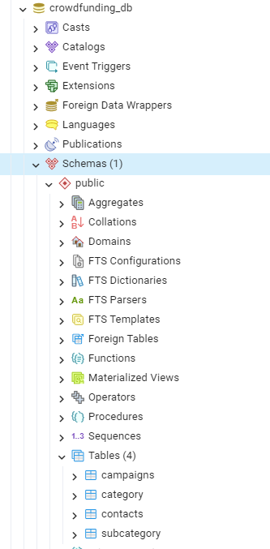

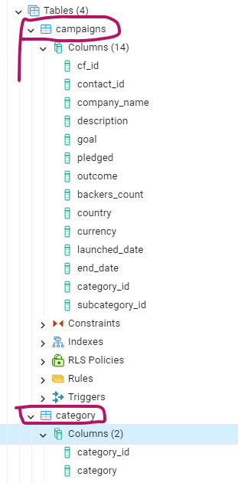

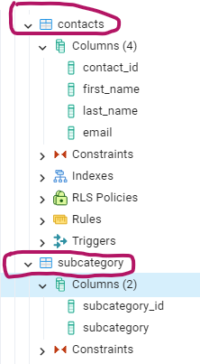

## Creating the tables in the database then running the query

### Category

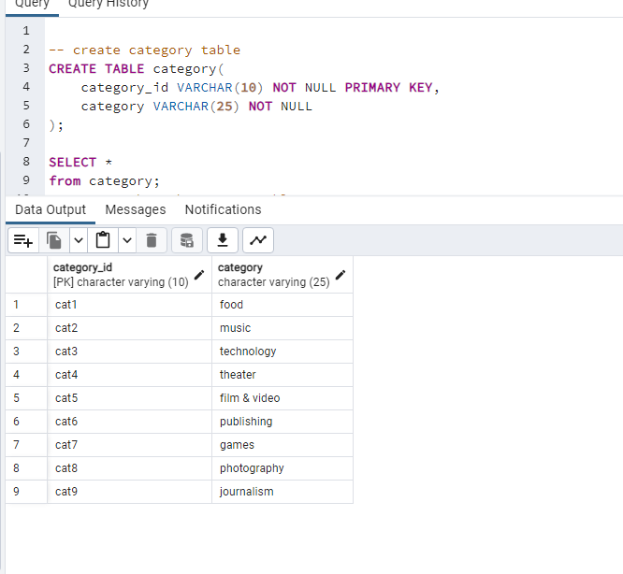

### Subcategory

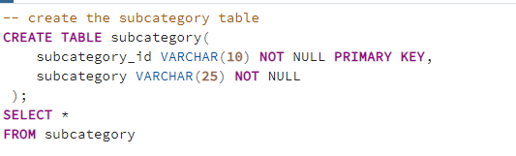

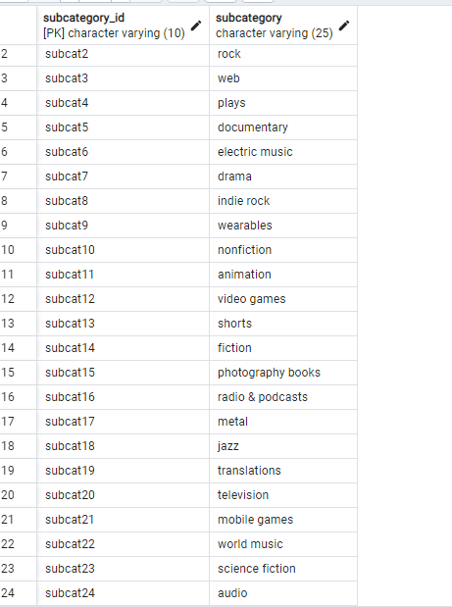

### Contacts

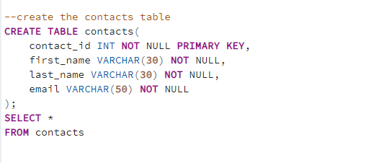

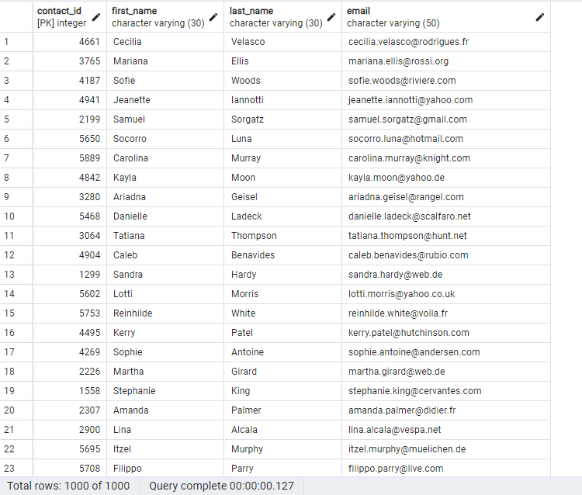

Campaign  
